

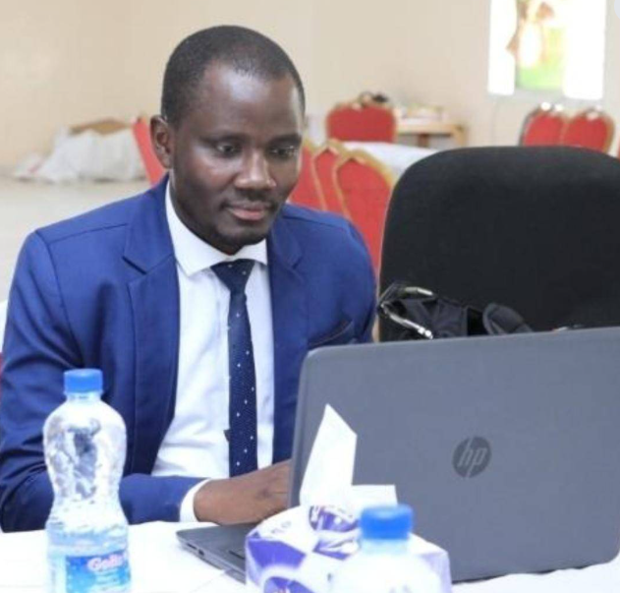

Dr. Samuel Otieno John

Director of Programs and Business Developemtn

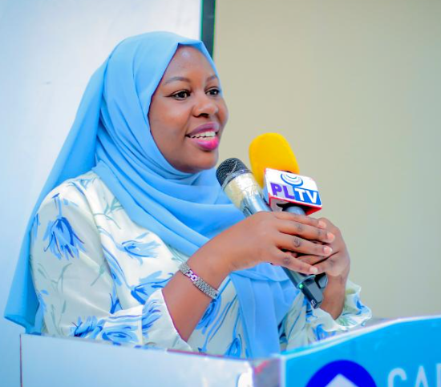

Dr. Flora Caroline Mwangi-Director of Administration and Finance

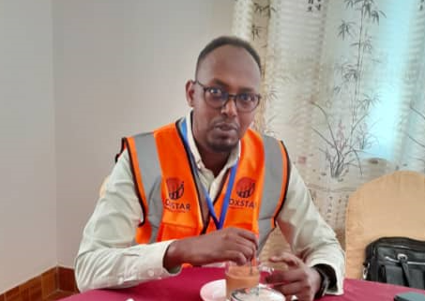

Mr. Abdisalam Mohamoud Ali- Programme Coordinator

# Summary OF SELECTED PROJECT PICTURES

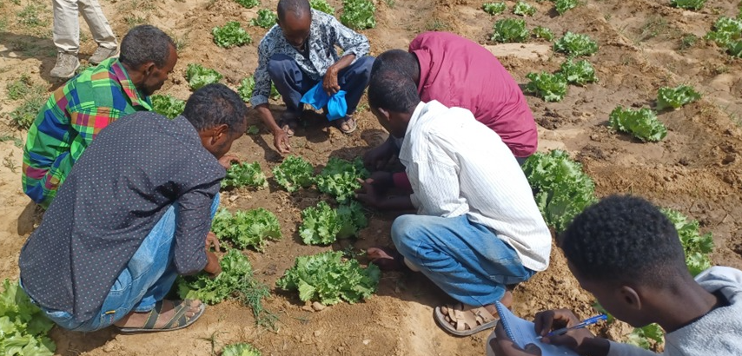

Figure 1: Training farmers on vegetable production in Arabsiyo district, Somaliland

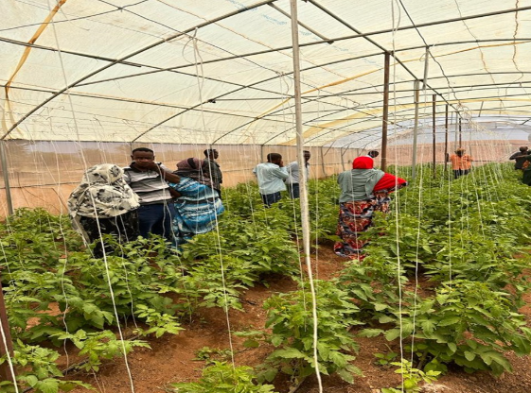

Figure 2: Training farmers on greenhouse best management practices in Gabiley district, Somaliland

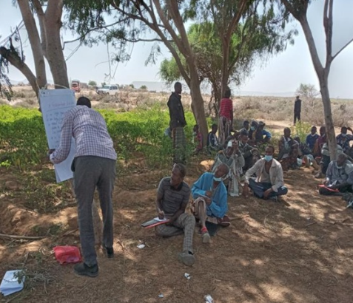

Figure 3: Oxstar program team conducting training agro-pastoral project beneficiaries in Burao district, Somaliland

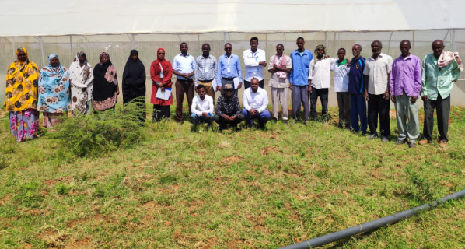

Figure 4: A group photo showing agro-pastoral project beneficiaries and Oxstar project team in Gabiley district, Somaliland

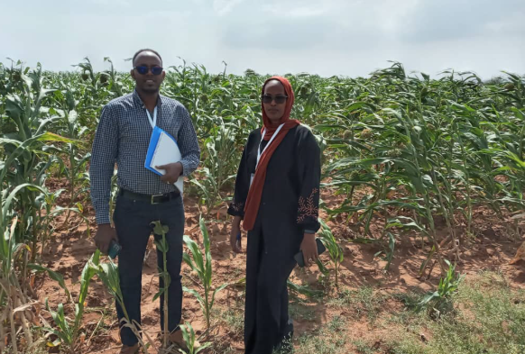

Figure 5: Oxstar Program team conducting field supervision, Burao district, Somaliland

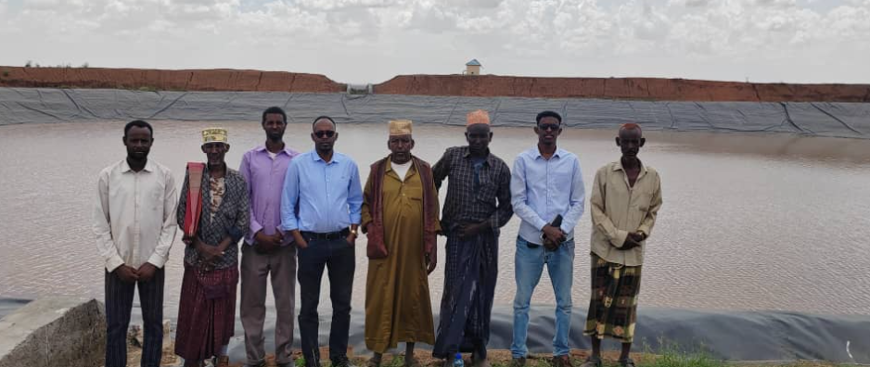

Figure 6: AYNRAD program team conducting field supervision

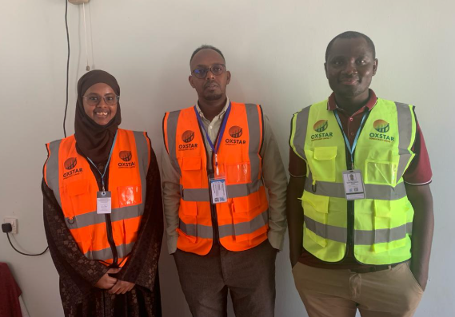

Figure 7: Oxstar team conducting Third-Party Monitoring of USAID funded projects in Hargeisa, Somaliland

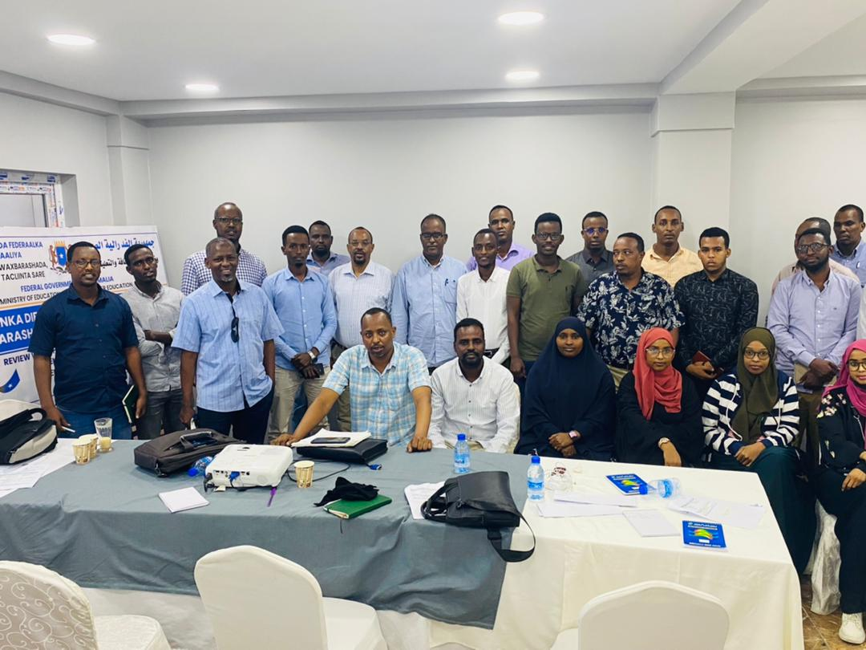

Figure 8: Oxstar Capacity-building for local NGOs in Banadir region, Mogadishu Somalia

**OXSTAR PICTURES**

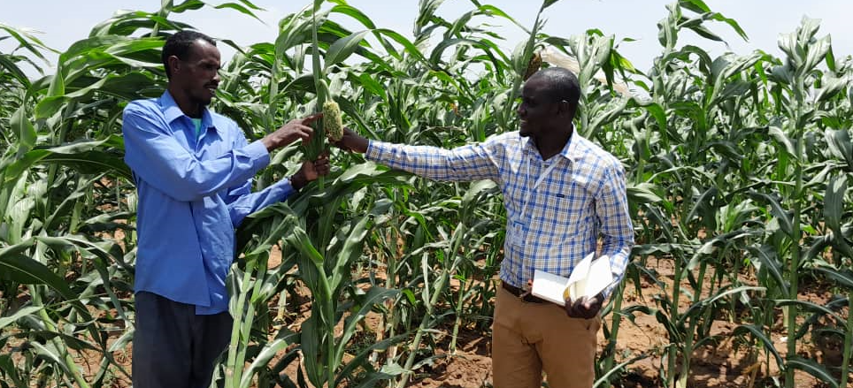

**Practical Seed Multiplication Training for improved Sorghum Seed Security in Somaliland**

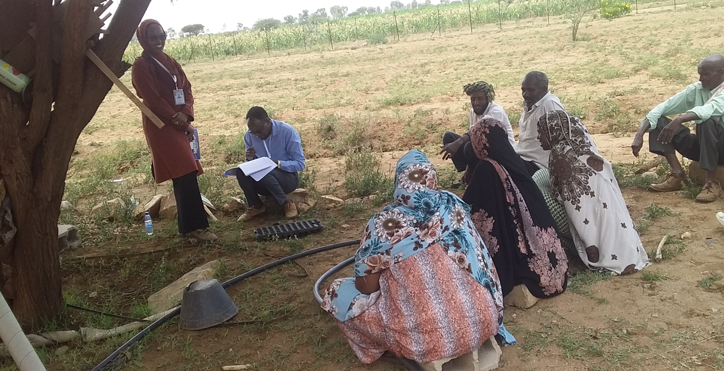

**Community Focus Group Discussion Session on Impact of Community-Seed Bank Project**

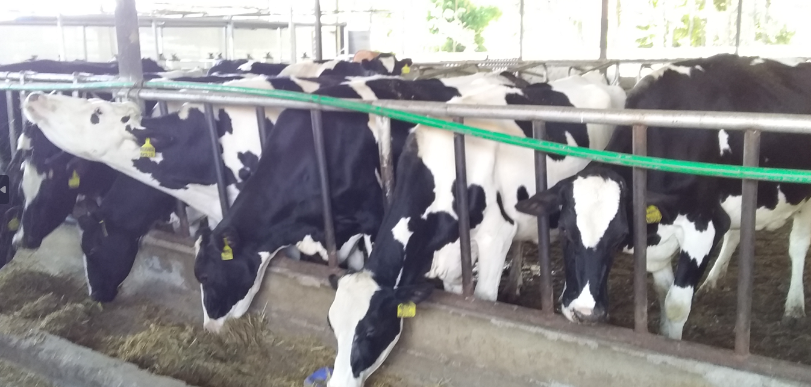

**Agribusiness Livestock rearing and feeding practices in Uasin Gishu County, Kenya**

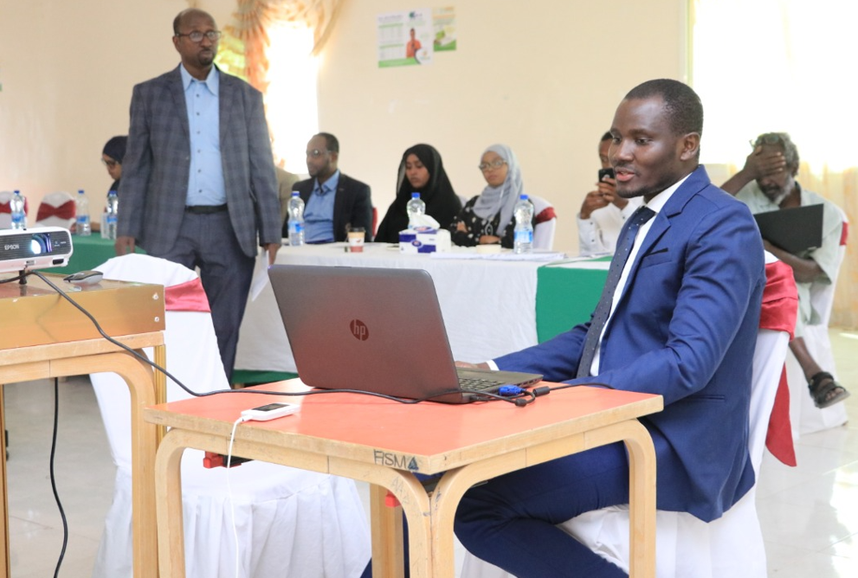

**Capacity building of Somaliland Government Officials on improved Monitoring and Evaluation of Health and Nutrition Programmes**

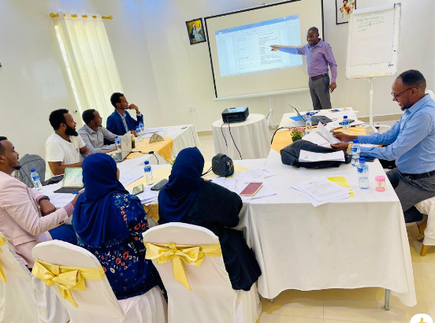

**Online Data Collection Training in Hargeisa City Somaliland**

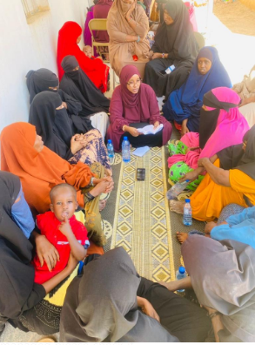

Infant and Young Child Feeding (IYCF) Group counseling Training in Maroodijeex region, Hargeisa Somaliland

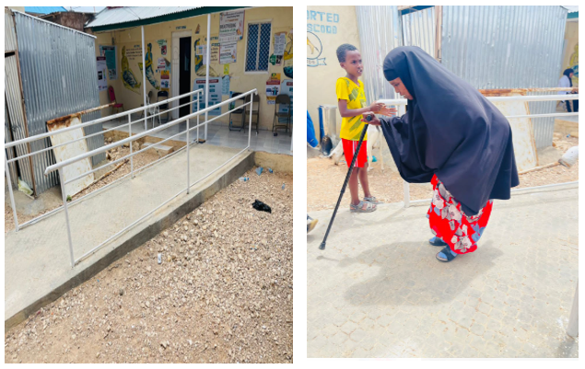

Third Party Monitoring and Verification of Renovated Infrastructure Projects for People with Disabilities in Somaliland and Puntland

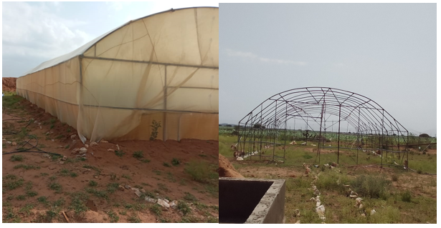

Installation of Green Houses in Burco and Gabiley District, Somaliland

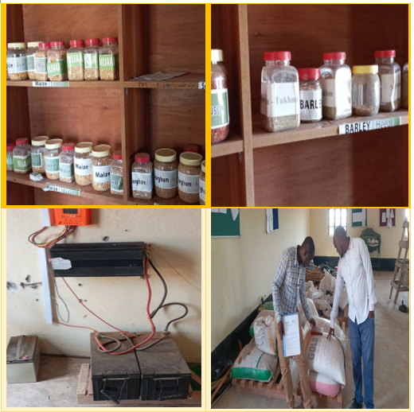

Monitoring the Progress of Community Seed Bank Project Gabiley District, Somaliland

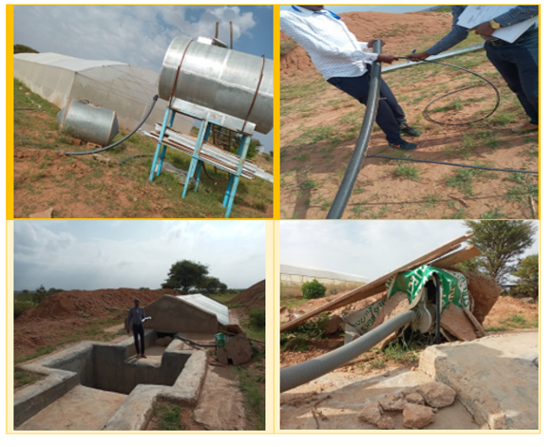

Practical demonstration of proper water Harvesting and Storage practices in Somaliland

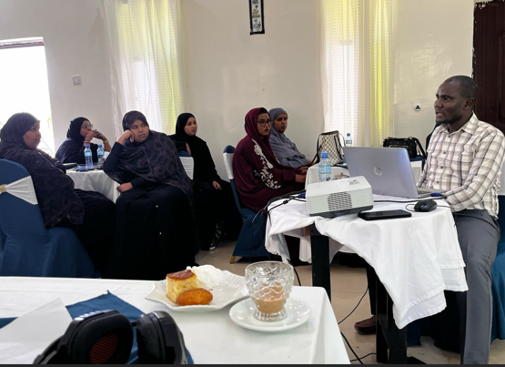

Gender Mainstreaming for local NGO staffs in Hargeisa, Somaliland